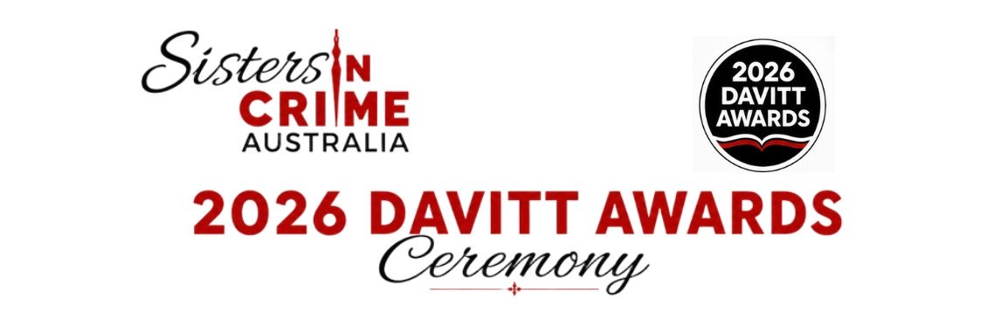

5 August 2026

Media Release
26th Annual Davitt Awards Ceremony:
Saturday 12th September, Stamford Plaza, Melbourne.

Sisters In Crime would like to invite you to the 2026 Davitt Awards Ceremony, and is excited to announce that special guest Dervla McTiernan, bestselling author of the Cormac Reilly novels, The Murder Rule, and What Happened to Nina? will be presenting the Davitt Awards to the 2026 winners. Sisters In Crime is also pleased to have Louise Milligan, a multi-Walkley award winning investigative journalist for Four Corner, as well as the best-selling author of Pheasants Nest, as host for the 2026 Davitt Awards Ceremony.
The 2026 Davitt Awards Ceremony is a time for us to come together to celebrate Australian women crime fiction writers. This year sees 14 books shortlisted across the following four categories; Adult Fiction, Non-Fiction, Young Adult, and Children’s Books. For the 2026 Davitt Awards shortlist please go to: https://sistersincrime.org.au/davitt-awards-2026/
As presenter Dervla McTiernan observes, “Australian crime writing is world class and it is an honour to be part of an evening that celebrates that. I am delighted to present this year's awards and to celebrate with so many of the writers whose work I admire. The Australian crime writing community is an incredibly close-knit and supportive community and I am proud to be part of it.
2026 Davitt Awards Ceremony details:
Sit-down dinner at the Stamford Plaza, 111 Little Collins St, Melbourne.
Saturday 12th September, 6:30pm
Dress code: Fabulous and Fearless
Ticket prices: $80 (Sisters In Crime member) or $95 (non-member)
Tickets must be purchased by Friday 4th September, and are available at: Sisters In Crime 2026 Davitt Awards Ceremony
**Please note that due to system difficulties we cannot accept payments made via PayPal.
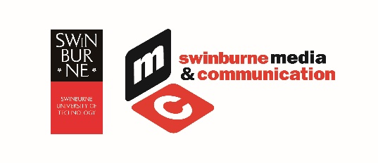
The Davitt Awards are once again supported by the Swinburne University of Technology

Media Contact: Ruth Wykes, Davitt Awards Judges’ Chair, email: davitts@sistersincrime.org.au or phone: 0407 898 754
Further information: https://sistersincrime.org.au/davitt-awards-2026/

