1 July 2025
Prize for Best Art and Crime Short Story Award – Sisters in Crime’s 32nd Scarlet Stiletto Awards
Sisters in Crime’s 32nd Scarlet Stiletto Awards for best short crime and mystery stories are offering $13,050 in prizes this year, including the Bolton Clarke Art and Crime Award, worth $1000.
Bolton Clarke Europa on Alma retirement community is now sponsoring the Art and Crime Award ($1000) that previously drew on a bequest by long-term member and sculptor, Viliama Grakalic.
Senior Retirement Village Manager Meredith Adams said: “We are excited to be a part of this year’s Scarlet Stiletto Awards, with many of our residents at Europa on Alma proudly involved in this inspiring women’s group. Supporting our residents to pursue interests and life-long learning is at the heart of what we do and the work Sisters in Crime does is a wonderful example of this.”
One of the Europa on Alma residents, retired Professor Caroline de Costa, has won two Scarlet Stiletto Awards, including the Art and Crime Award – this on top of four Cass Diamond police procedurals (plus a prequel) set in Cairns.
Stories entered for the award need to involve art and crime. They can include artists, the art world, galleries, art collections, museums, theft, fakes, fraud, forgeries or heists and art forms such as painting, drawing, sculpture, jewelry and photography.

“Authors need to get cracking,” said Ruth Wykes, the Scarlet Stiletto Awards coordinator. “Entries close on 31 August – and it’s worth firing up the laptop (or sharpening the pencil).
“Over $13,000 in prize money shows that crime does pay – at least on the page. And writing is a lot less risky than holding up your local service station or committing art fraud.”
The Cate Kennedy Award for Best Story Inspired by a Forensic Clue ($500) – is being offered for a second time this year, and may also appeal to the artistically inclined. Kennedy, who won the first two Scarlet Stiletto Awards in 1994 and 1995, and rapidly became one of Australia’s most admired and awarded short-story writers (even having a story published in the New Yorker) said the new ‘forensic clue’ was a photo of two scarlet stilettos, a notebook, and passport, abandoned in a garden.
“I won a pair of shoes in the first days of the Scarlet Stiletto Awards, and was a bit freaked out having the stiletto blade glinting on the bookshelf, so I gave the shoes away to a friend who put them on display in her very whimsical sculpture garden, and kept the bases as bookends. They now hold up a whole bookcase, and keep everything else in place, which is nicely symbolic when I read the bios of the other writers who have won Scarlet Stiletto Awards over the years,” Kennedy said.
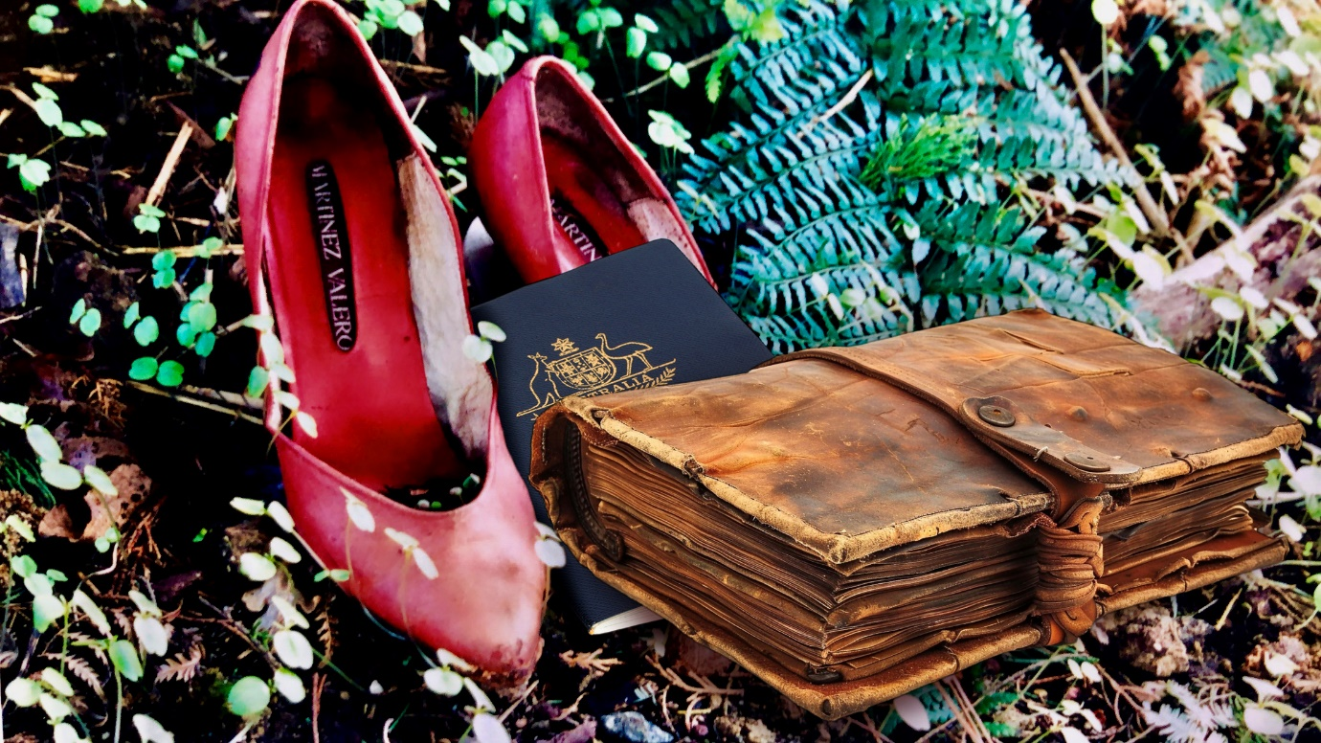
Kennedy credits the Scarlet Stiletto Awards as a major influence and support in her literary career, and has returned over the years as both judge and award presenter.
“I often find myself inspired by odd snapshots and small, intriguing news stories as a springboard to write a new story,” she said, “because I like that ‘what if…?’ feeling of unexplained secrets and private, out-of-the-limelight little dramas which might become a satisfying crime short story. I hope writers feel inspired to create a little world out of this one.”
Wykes said that Sisters in Crime was thrilled that sponsors had continued their support despite these financially fraught times. Several sponsors had also upped the amount on offer.
“Our sponsors are a diverse bunch. What they have in common is an unswerving commitment to women’s writing. which has paid off in spades. Since the awards began 32 years ago, 4777 stories have been entered and 34 winners – including winners of the Shoe and category winners –going on to have books published,” she said.
Sixteen collections of winning stories are available from Clan Destine Press, along with a hardcopy Scarlet Stiletto collection of the first-prize winning stories, The Scarlet Stiletto: 30 Years of Mystery, Murder and Malice, edited by Lindy Cameron. (paperback $36.99; e-book $7.99).
Closing date for the awards is 31 August 2025. The entry fee is $25 or $20 for Sisters in Crime members. Maximum length is 5000 words. The shortlist will be announced in October and the awards will be presented at a ceremony in Melbourne in late November.
The competition is open to all women, whether cisgender, transgender or intersex, who are citizens/residents of Australia.
To download an entry form, a list of FAQs, a registration form, and pay the entry fee go to:
https://www.sistersincrime.org.au/the-scarlet-stiletto-awards/
The full list of this year’s awards is:
- Swinburne University Award: 1st Prize: $2000
- Simon & Schuster Award: 2nd Prize: $1000
- Sun Bookshop & Fremantle Press Award: 3rd Prize: $800
- Echo Publishing for Best Young Writer (under 19): $1000
- Melbourne Athenaeum Library ‘Body in the Library’ Award: $1250 ($750 runner-up)
- HQ Books Award for Best Thriller: $1200
- Kerry Greenwood Award for Best Malice Domestic Story: $1000
- Every Cloud Phryne Award for Best Mystery with History Story: $1000
- Bolton Clarke Art and Crime Award: $1000
- Clan Destine Press Award for Best Cross-genre Story: $750
- Cate Kennedy Award for Best Story Inspired by a Forensic Clue: $500
- ScriptWorks Award for a Great Film Idea: $500
- Writers Victoria Award for the Story with the Most Satisfying Retribution: Choice of online course plus membership, worth $300.
Additional information: Ruth Wykes, Scarlet Stiletto Awards Coordinator: 0407 898 754; ssaentries2025@gmail.com

