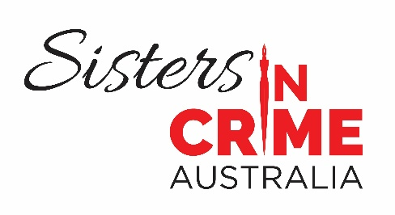

June 2025
32nd Scarlet Stiletto Awards now open – $13,050 up for grabs
More female criminal talent – of the literary kind – is about to be uncovered, thanks to Sisters in Crime’s 32nd Scarlet Stiletto Awards for Australian women’s best short crime and mystery stories. The 2025 round, just announced, offers $13,050 in prizes.
Professor Emerita Christina Lee, Judges’ Coordinator and winner of two trophies, said the Scarlet Stiletto Awards were remarkable in their ability to discover outstanding criminal talent.
“Winning a Scarlet Stiletto Award has often been a springboard to a literary career. To date, 4777 stories have been entered, with 34 Scarlet Stiletto Award winners – including category winners – going on to have novels published,” she said.
“Well-known authors who got their start with the Scarlet Stiletto Awards include Cate Kennedy, Tara Moss, Aoife Clifford, Ellie Marney, Angela Savage, and Anna Snoekstra. For Dervla McTiernan, just being shortlisted in 2015 gave her the impetus to finish five drafts of her first novel, The Rúin, and put her on the road to becoming a global publishing sensation.”
The first prize winner takes home $2000, donated by Swinburne University of Technology, plus the coveted trophy, a scarlet stiletto shoe with a steel stiletto heel plunging into a mount. The shortlist will be announced in October, with the awards being presented at a gala ceremony in Melbourne in late November.
Echo Publishing is the new sponsor of the Best Young Writer Award ($1000). Juliet Rogers, Managing Director and Publisher, said: “We are so delighted to be sponsoring the Best Young Writer Award in Sisters in Crime 32nd Scarlet Stiletto short story competition, as we are passionate about both new writing and crime fiction. We have also witnessed the wonderful support that Sisters in Crime give to writers, both old and new, so sponsoring their award for young writers is the perfect partnership for Echo.”
The Best Young Writer Award has unearthed literary stars such as Tara Moss who went on to write five novels in her stiletto murderer series (amongst other things).
Bolton Clarke Europa on Alma retirement community is now sponsoring the Art and Crime Award ($1000) that previously drew on a bequest by long-term member and sculptor Viliama Grakalic.
Senior Retirement Village Manager Meredith Adams said: “We are excited to be a part of this year’s Scarlet Stiletto Awards, with many of our residents at Europa on Alma proudly involved in this inspiring women’s group. Supporting our residents to pursue interests and life-long learning is at the heart of what we do and the work Sisters in Crime does is a wonderful example of this.”
One of the Europa on Alma residents, retired Professor Caroline de Costa, has won two Scarlet Stiletto Awards, including the Art and Crime Award – this on top of four Cass Diamond police procedurals (plus a prequel) set in Cairns.
The Cate Kennedy Award for Best Story Inspired by a Forensic Clue ($500) is being offered for a second time this year. Kennedy, who won the first two Scarlet Stiletto Awards in 1994 and 1995, and rapidly became one of Australia’s most admired and awarded short-story writers (even having a story published in the New Yorker) said the new ‘forensic clue’ was a photo of two scarlet stilettos, a notebook, and passport, abandoned in a garden.
“I won a pair of shoes in the first days of the Scarlet Stiletto Awards, and was a bit freaked out having the stiletto blade glinting on the bookshelf, so I gave the shoes away to a friend who put them on display in her very whimsical sculpture garden, and kept the bases as bookends. They now hold up a whole bookcase, and keep everything else in place, which is nicely symbolic when I read the bios of the other writers who have won Scarlet Stiletto Awards over the years,” Kennedy said.
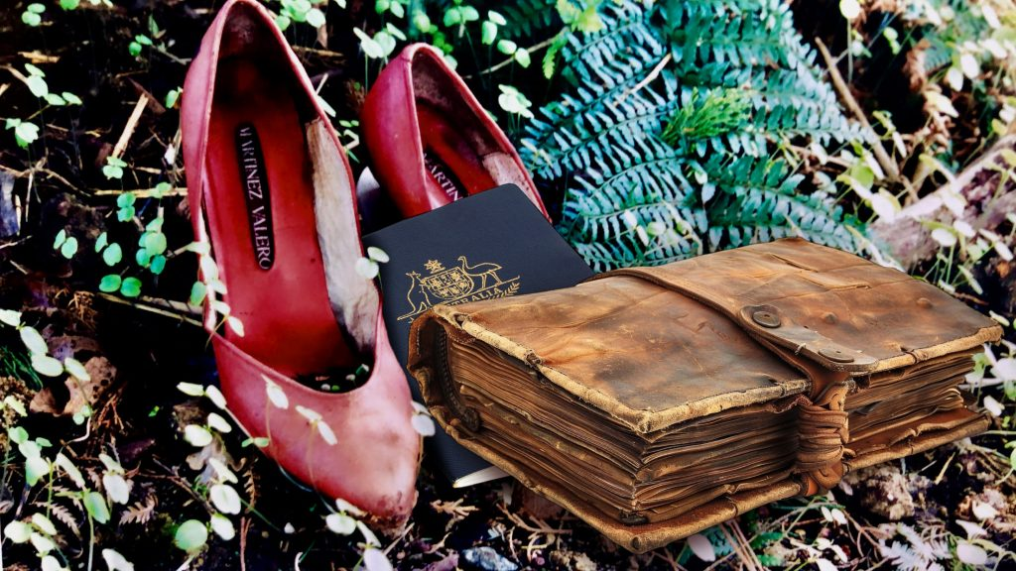
Kennedy credits the Scarlet Stiletto Awards as a major influence and support in her literary career. She has returned over the years as both judge and award presenter.
“I often find myself inspired by odd snapshots and small, intriguing news stories as a springboard to write a new story,” she said, “because I like that ‘what if…?’ feeling of unexplained secrets and private, out-of-the-limelight little dramas which might become a satisfying crime short story. I hope writers feel inspired to create a little world out of this one.”
Like many of Sisters in Crime’s best ideas, the Scarlet Stiletto Award sprang from a well-lubricated meeting in St Kilda in 1994, when the convenors debated how they could unearth the hidden female criminal talent they were convinced was out there.
“Once a competition was settled on, it didn’t take long to find a name – the scarlet stiletto, a feminist play on the traditions of the genre. The stiletto is both a weapon and a shoe worn by women. And of course, the colour scarlet has a special association for us as women. And they were right – talent is lurking everywhere, sometimes in the most unlikely places,” Professor Lee said.
All of the first-prize winning stories over the past 31 years plus others have been narrated by Susanna Lobez for Sisters in Crime’s very first podcast – Scarlet Stiletto Bites: Scintillating stories by Australian women. Altogether, 76 stories have been podcast. They are available on Spotify, Amazon Music , RSS, PodcastAI, and other services.
The full list of awards is:
Swinburne University Award: 1st Prize: $2000
Simon & Schuster Award: 2nd Prize: $1000
Sun Bookshop & Fremantle Press Award: 3rd Prize: $800
Echo Publishing for Best Young Writer (under 19): $1000
Melbourne Athenaeum Library ‘Body in the Library’ Award: $1250 ($750 runner-up)
HQ Books Award for Best Thriller: $1200
Kerry Greenwood Award for Best Malice Domestic Story: $1000
Every Cloud Phryne Award for Best Mystery with History Story: $1000
Bolton Clarke Art and Crime Award: $1000
Clan Destine Press Award for Best Cross-genre Story: $750
Cate Kennedy Award for Best Story Inspired by a Forensic Clue: $500
ScriptWorks Award for a Great Film Idea: $500
Writers Victoria Award for the Story with the Most Satisfying Retribution: Choice of online course and membership.
Sixteen collections of winning stories are available from Clan Destine Press, along with a hardcopy Scarlet Stiletto collection of the first-prize winning stories, The Scarlet Stiletto: 30 Years of Mystery, Murder and Malice, edited by Lindy Cameron. (paperback $36.99; e-book $7.99)
The closing date for the awards is 31 August 2025. The entry fee is $25, or $20 for Sisters in Crime members. Maximum length is 5000 words.
The competition is open to all women, whether cisgender, transgender, or intersex, who are citizens/residents of Australia.
To download information and a list of FAQs, go to:
https://www.sistersincrime.org.au/the-scarlet-stiletto-awards/
To pay the entry fee, go to https://www.eventbrite.com/manage/events/1416060307499/details
Media comment: Professor Emerita Christina Lee; 0424 003 285; c.lee@psy.uq.edu.au
Additional information: Ruth Wykes, Scarlet Stiletto Awards coordinator: 0407 898 754 ; ssaawards2025@gmail.com

