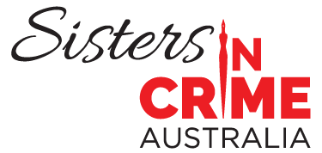
ORDER FORM FOR MERCHANDISE
I would like to purchase the following items:
T shirt
Size | Colour | Price per t shirt | No. of shirts | Total
Small | Black | $40.00
Small | Red | $40.00
Small | Purple | $40.00
Medium | Black | $40.00
Medium | Red | $40.00
Medium | Purple | $40.00
Large | Black | $40.00
Large | Red | $40.00
Large | Purple | $40.00
X large | Black | $40.00
X large | Red | $40.00
X large | Purple | $40.00
2XL | Black | $40.00
2XL | Red | $40.00
2XL | Purple | $40.00
3XL | Black | $40.00
3XL | Red | $40.00
3XL | Purple | $40.00
4XL | Black | $40.00
4XL | Red | $40.00
4XL | Black | $40.00
4XL | Red | $40.00
5XL | Black | $40.00
5XL | Red | $40.00
 |  | Totals
Tote bags
Title | Price per bag | No of bags | Total
Tote bag | $45.00
 |  | Grand total
Note: postage within Australia is included. This is standard Australia Post.
Please send my order to:
First name
Last name
Address line 1
Address line 2
Suburb/City
Postcode
Country
Email

Please charge my credit card as follows:
Circle one VISA MASTERCARD

Card name
Card number
Expiry
CVV (on reverse of card)
Signature
Date today

Send this form to
Sister in Crime Australia
PO Box 357,
Balaclava Vic 3183
Or email a scan to admin@sistersincrime.org.au
Sisters in Crime Australia is incorporated in Victoria.
ABN 42 845 157 713
ARBN 650 603 053
A0041648U

